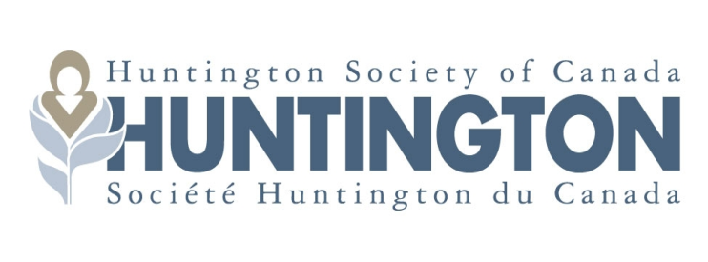

2022 RESEARCH COMPETITION
LETTER OF INTENT
NAVIGATOR RESEARCH GRANT

The Letter of Intent is comprised of the following:
- Parts A1, A3 and B of the Navigator Application for 2022
- This 2022 LOI Form
- Attachments: an abbreviated CV (max 2 pages) for the applicant and any co-applicants which includes information on grants held, relevant publications from the last five years and a brief biography of any references cited in the Letter of Intent.
PI NAME AND INSTITUTION:
PROJECT TITLE:
LAY SUMMARY
(text must fit in this area only)

PROJECT INFORMATION: GOALS AND SPECIFIC AIMS
(text must fit in this area only)

BACKGROUND AND SIGNIFICANCE
(text must fit in this area only)

EXPERIMENTAL APPROACH, INCLUDE MODEL SYSTEMS
(text must fit in this area only)

HOW WILL A SUCCESSFUL OUTCOME ACCELERATE KNOWLEDGE OF DEVELOPMENT OF THERAPEUTICS FOR HD?
(text must fit in this area only)

