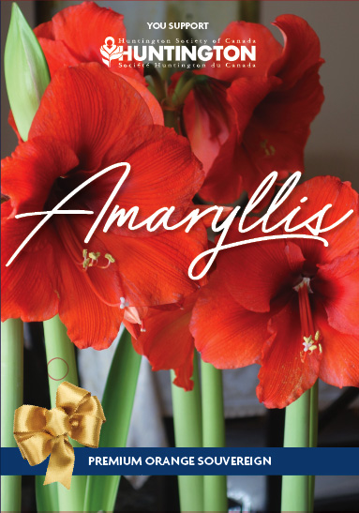
2018 Amaryllis Order Sheet

Every fall, the Huntington Society of Canada sells Amaryllis bulbs to raise funds for programs for people living with Huntington disease (HD). The Amaryllis is a bright symbol of awareness for HD. The Amaryllis makes a beautiful gift for many occasions:
• Holiday Parties | • Employee or Customer Appreciation
• Thank you to teachers | • Friends, Co-workers or Family members
• Housewarming | • To brighten up a loved one’s room

Please support the 2018 Amaryllis Campaign.
Your help inspires hope.

Huntington disease is a genetic neurological disorder. About one in every 7,000 Canadians has HD, but one in every 1,000 is touched by HD whether at risk, as a caregiver, family member, or friend. The HD gene is dominant, which means that each child born to a parent with Huntington disease has a 50% chance of sharing the same fate.

For more details contact:

Your Name (please print) | Your Phone # | # of Bulbs you wish  to order $15 each | Total Cost  of your order | Paid
Total Collected |  |  |  | $

On behalf of the families affected by Huntington disease, thank you. Your support is deeply appreciated.
Huntington Society of Canada
151 Frederick St, Suite 400, Kitchener, Ontario N2H 2M2
1-800-998-7398 - amaryllis@huntingtonsociety.ca - www.inspirehope.ca
Charitable Registration Number 11896 5516 RR0001

