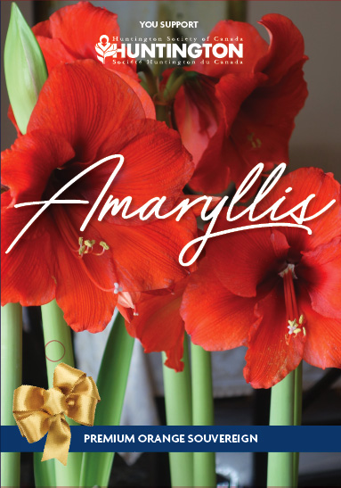
2019 Amaryllis Order Sheet

Every year, the Huntington Society of Canada sells Amaryllis bulbs to help raise money for programs and services for people affected by Huntington disease (HD). The Amaryllis is a bright symbol of hope and awareness for HD and can be a offered as a wonderful gift for many different occasions:
• Holiday parties | • Employee or customer appreciation
• Thank you for teachers | • Friends, co-workers or family members
• Housewarming | • To brighten up a loved one’s room

We warmly welcome your support in the 2019 Amaryllis Campaign. Your help inspires hope.

Huntington disease is a hereditary, neurodegenerative illness with physical, cognitive and emotional symptoms. About one in every 7,000 Canadians has HD, but one in every 1,000 is touched by HD, whether at risk, as a caregiver, family member, or friend. The HD gene is dominant, which means that each child of a parent with HD has a 50% chance of inheriting the disease and is said to be at-risk. To date, there are no drugs to slow or stop the progression of HD; however, there are specific drugs available to reduce some of the symptoms. Research is being conducted in Canada and globally to find promising treatments and approaches to treating HD.

For more details contact:

Your Name (please print) | Your Phone # | # of Bulbs you wish  to order ($15 each) | Total Cost  of your order | Paid
Total Collected |  |  |  | $

On behalf of the families affected by Huntington disease, thank you. Your support is deeply appreciated.
Huntington Society of Canada
151 Frederick St, Suite 400, Kitchener, Ontario N2H 2M2
1-800-998-7398 - amaryllis@huntingtonsociety.ca - www.inspirehope.ca
Charitable Registration Number 11896 5516 RR0001

