November 2015 Monthly News Bulletin

Dear Enroll‐HD Investigators and Site Staff,

An Enroll-HD progress update over the past month:

Enroll-HD data access and website update
- The new Enroll-HD website is live – and the first release of the coded Enroll-HD periodic dataset is available there to any researcher employed at a recognized research institution or company. You can learn more about the types of data and biosamples that are available and the simple and straightforward process to access the Enroll-HD dataset and biosamples. If you’re a principal investigator at an Enroll-HD clinical site then your login details for the EDC system will also allow you to access the periodic dataset.
- Also on the Enroll-HD website you can find lots of information about how the study is structured and the people who keep it running, from site staff to participants to clinicians to researchers. Please share the link with your colleagues and your participants and check back often for new articles, updates and announcements.
- Please also check that the information listed on the website for your site is current and correct; please email any corrections to EnrollHD@quintiles.com

Enroll! Quarterly newsletter for participants, families, and site staff
- The Autumn 2015 issue of Enroll! is being circulated with this month’s bulletin. This has been approved for distribution in the United States and Canada by the central IRB being utilized for Enroll-HD, Western Institutional Review Board (WIRB). Please ensure that you follow all local rules and regulations that apply to your site prior to distribution (including any submission and/or review requirements by your local IRB/EC).
- For logistical reasons print copies will not be distributed, but you are encouraged to print locally (in color if possible) so that participants and their family members can take a copy with them. Please contact the Enroll-HD Study Team with any questions.

Recruitment update
- As of November 1st, a total of 8,140 participants have been enrolled at 126 sites in 13 countries around the world.

Regional startup and enrollment updates
NORTH AMERICA:
- 3,663 participants have been enrolled at 57 active sites in the US and Canada.
- An additional 13 sites have begun the site start-up process.

AUSTRALASIA:
  - 367 participants have been enrolled at five active sites in Australia and New Zealand.
  - Two additional sites have begun the site start-up process.

LATIN AMERICA:
- 120 participants have been enrolled at two active sites in Argentina and Chile.
- Start-up efforts continue at 10 sites in Argentina, Brazil, Chile, and Peru.

EUROPE:
- 3,990 participants have been enrolled at 63 active sites in Denmark, Germany, Poland, Italy, Netherlands, Spain and the UK.
- 31 additional European sites that will participate in Enroll-HD now have fully executed contracts.

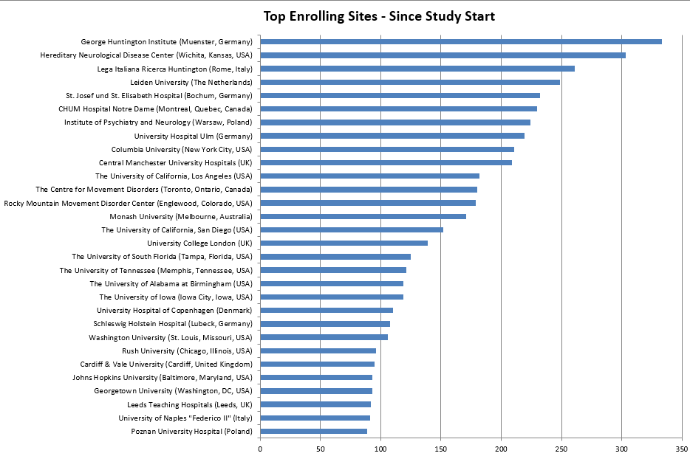

The top enrolling site is George Huntington Institute (Muenster, Germany) with 333 participants enrolled!

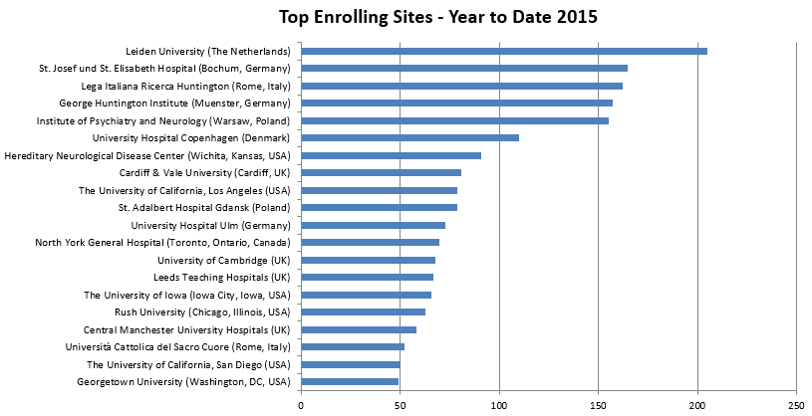

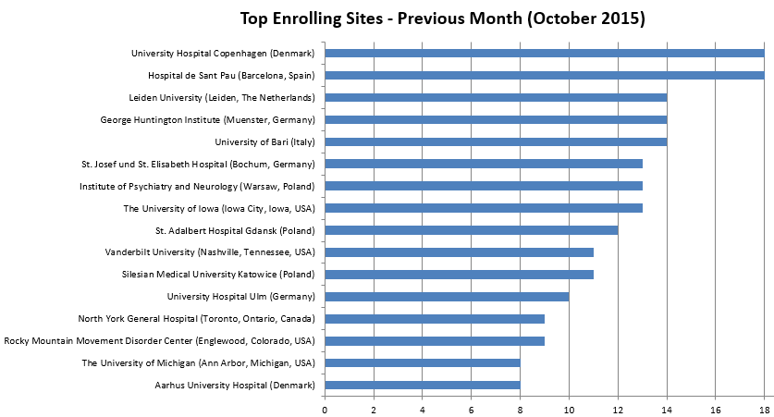

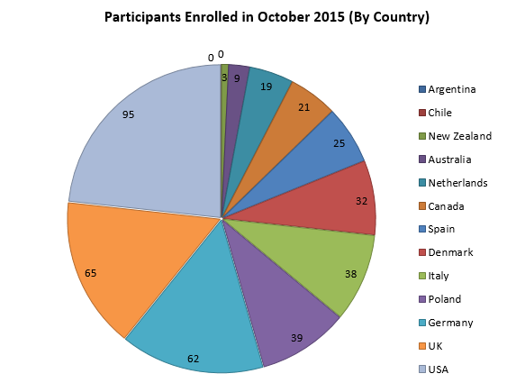

Thank you for your support in helping Enroll-HD achieve its goals.

The Enroll-HD Study Team

